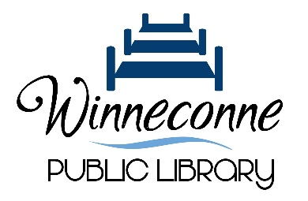
Winneconne Public Library
31 S 2nd Street • P.O. Box 518 • Winneconne, WI 54986-0488
920-582-7091 • www.winneconnelibrary.org

Quorum Notice
Winneconne Public Library
Thursday August 29th at 5:30pm
Kelly Nelson’s Book Launch Event

Notice is hereby given that a quorum of the Winneconne Public Library Board of Trustees might be present for the special event, Kelly Nelson’s Book Launch on Thursday August 29th at 5:30pm.

Though no Library business will be acted on, this notice is being posted to comply with Wisconsin Open Meetings Law, which requires public notice to be given when a quorum of a governmental body may be gathered together, unless the event is for educational purposes only.

Posted this 26th day of August 2024.

Amanda O’Neal
Winneconne Library Director

